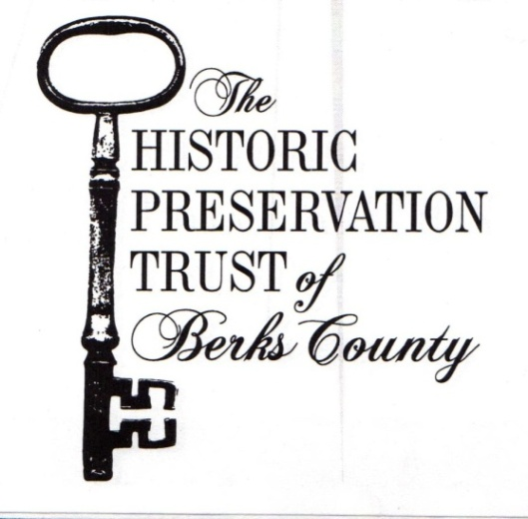
Old Morlatton Village
M e s s e n g e r
Volume XXVII Number 3 Fall 2017

Keim Music Fest at the Keim Homestead
Saturday, September 30, 2017 • 11am-5pm
A benefit for the restoration of the Keim Homestead

2 Music Stages Including a Kid & Family Stage • Activities for Children
Food available for purchase • Bring instruments, lawn chairs, blankets
Tickets available day of event – $10 donation (Ages 10+)
More info at www.keimfest.com

Contact Us!

P.O. Box 245
Douglassville, PA 19518
610-385-4762
info@historicpreservationtrust.org

In This Issue
Upcoming Events | 2
Volunteering | 3
Keim Open House Photos | 3
Board of Directors | 4
Site Hours & Rentals | 4
Sites & Structures Report | 5
President’s Report | 5
Matching Grant | 6
Membership Form | 6

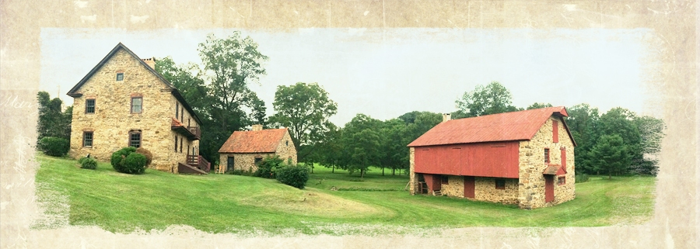

’
HPTBC Annual Dinner “The Keim Homestead: A National Historic Landmark”
at the Reading Public Museum
Saturday, November 4, 2017 • 6-9pm

This year’s annual dinner will celebrate the Keim Homestead. Join us for dinner, a silent auction, and a special presentation honoring Berks County’s third National Historic Landmark. Advanced tickets required. Invitations will be sent in early September. If you do not receive one and wish to attend, please contact us and one will be sent to you!

Upcoming Events at a Glance

Sept. 16 – 3rd Saturday Program
Sept. 30 – Keim Music Fest
Oct. 21 – 3rd Saturday Program
Nov. 4 – Annual Dinner
Dec. 6 – Christmas Tea
Dec. 16 – A Tavern Christmas

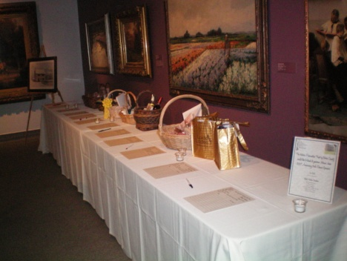
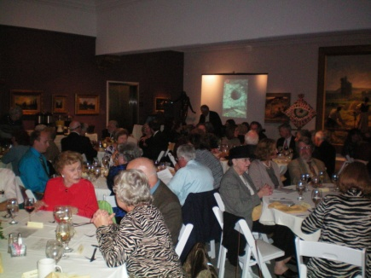

Additional Upcoming Events & Programs

3rd Saturday Programs at Morlatton Village
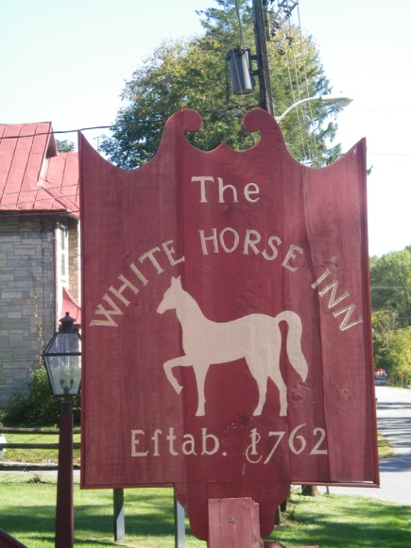
We are happy to announce a new series of programs: The 3rd Saturday Program at Morlatton Village. These programs will fall on the third Saturday of the month – April-October. These site-wide programs will include various formats and topics including exhibits, demonstrations, interactive sessions, and oral and graphic presentations. $2/Person Suggested Donation.

September 16 – “Your Eighteenth Century Kitchen Garden”
Join Trust volunteers Sue Speros and Dr. Courtney Stevens to learn more about the importance of gardens in the eighteenth century. Gardens were the “medicine chests” for the farms, the source of flavorful herbs for cooking, and provided lovely simple flowers that could bring beauty to a home.

October 21 – Topic TBD
___________________________________________
Ghosts along the Schuylkill with Charlie Adams
Saturday, September 23 & October 14, 2017• 6-9pm

The Trust is once again partnering with Ridgewood Winery, and this year will be hosting two Charlie Adams events at the White Horse Inn. Guests will visit both the White Horse and the Winery as well as one other site and hear all about their ghostly inhabitants. Advanced tickets required.
___________________________________________
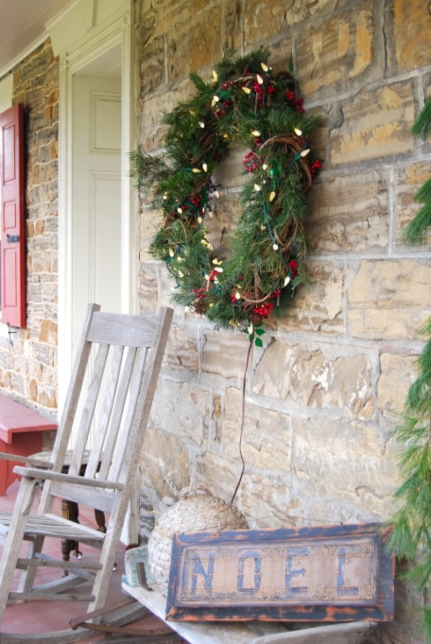
Christmas Tea
Wednesday, December 6, 2017

The Trust will once again be offering in annual Christmas Tea. Join us for a traditional tea featuring delightful homemade tea sandwiches and cookies, as well as delicious coffee and tea. Invitations for the Christmas Tea will be sent in early November. If you do not receive one and wish to attend, please contact us.
________________________________________
A Tavern Christmas
Saturday, December 16, 2017

The Trust is excited to offer a new holiday event! Join us for music, dancing, and wine tasting in the rustic atmosphere of an authentic eighteenth century tavern. We will have festive, fun crafts for children and there might even be a visit from the Belschnickel.

Events subject to change. For more information about our events, and to stay up-to-date on all Trust happenings, please check our website and Facebook page.

All events & programs begin at the White Horse Tavern in Morlatton Village unless otherwise noted.

Photos from the Keim Homestead Open House & National Historic Landmark Designation Celebration
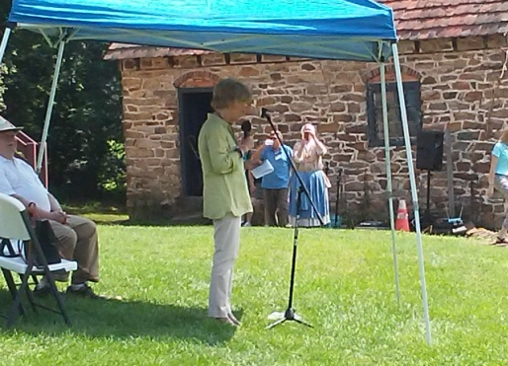
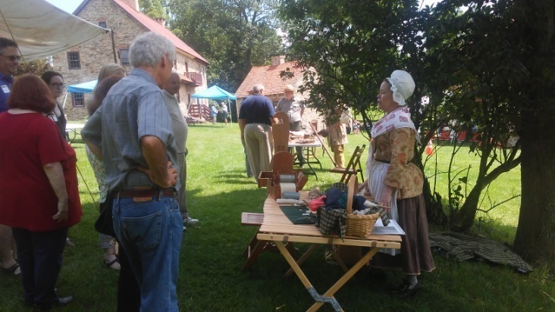

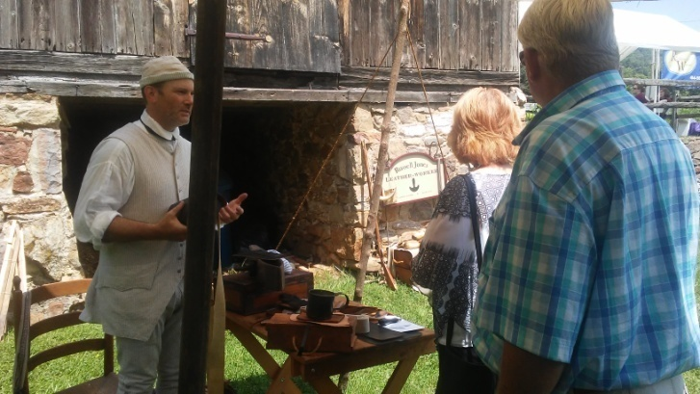
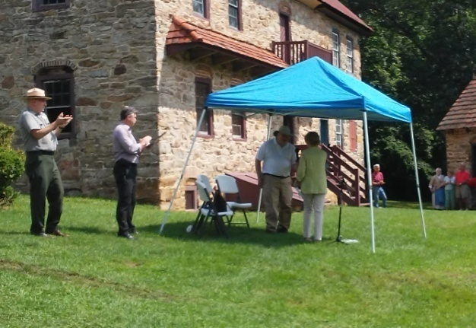

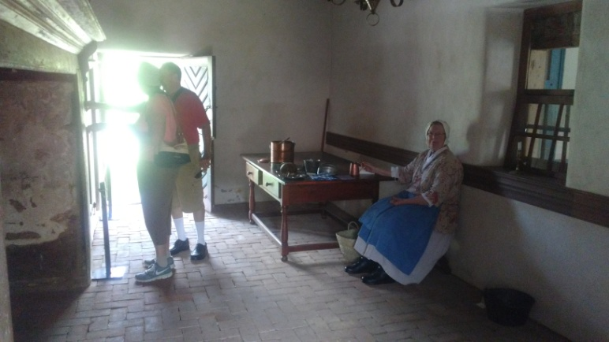
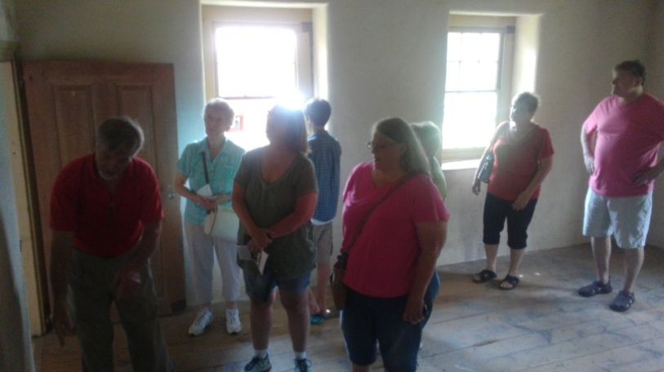

V o L u N t E e R !

None of these great events would be possible without our dedicated volunteers! The Trust is always in need of help and even if you are not a history buff or interested in historic preservation, we’ve still got a job for you! We can use help with outdoor clean-up, ticket sales & parking for events, as well as historic demonstrators & tour guides. We can even use help cleaning the buildings and setting up for events. We will especially need volunteers for our fall and winter events –the Keim Music Fest, Christmas Tea, & A Tavern Christmas.

Or, are you, or do you know a Boy Scout or Girl Scout who is looking for community service hours or to do an Eagle Scout project? You can help preserve the local history while earning hours, a badge, or even your Eagle Scout award. This also applies to civil service groups and students who need service hours. Why not learn and help preserve history while having fun?

If you or someone you know is interested in volunteering or if they are interested in working on projects at one of our historic buildings please contact us at (610) 385-4762 or info@historicpreservationtrust.org.
Fall Hours for Morlatton Village

Wednesday & Saturday 9am-12pm (through October)

Feel free to stop by and look around as well as visit the other historic buildings in Morlatton during open hours or by appointment for tours or visits. For details and changes please check the Trust’s Facebook page or website.

White Horse Rentals

From weddings and birthday parties to small meetings and gatherings, the White Horse Inn is the perfect setting for your special occasion. Located in historic Morlatton Village, Douglassville, the White Horse has a modern kitchen and seating for up to 50 guests. For more information about renting this fully restored eighteenth century building, please contact the Trust’s office at 610-385-4762 or info@historicpreservationtrust.org.

Board of Directors

John Hibschman, President
Bradford Kissam, Vice President
John Meinhart, Treasurer
Lauren Archibald, Recording Secretary
Amber Aman
Peter Hammond
Vicky Heffner
Thomas Keim
Jessica Kerns
Jim Lewars
Zachary Long
Michelle Lynch
Amanda Machik
Vickie Moyer
Sue Miller Speros

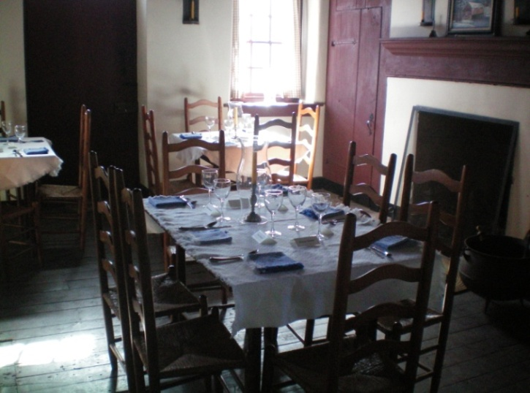

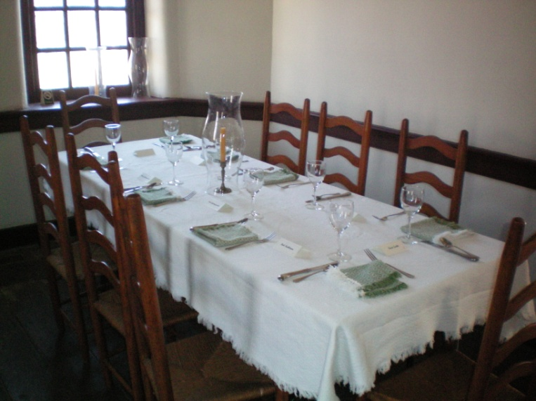

Help the Trust ‘go green.’ If you have an email address and would not mind getting electronic communications from us, please make sure to provide it on your next dues renewal or just send us an email.

Follow us on Facebook at Historic Preservation Trust of Berks County

Sites & Structures Update

October 21 is International Archaeology Day and the Chapter 21 volunteer archaeologists will be presenting their latest findings that day at the Mouns Jones House Root Cellar, including the original stone-arched entry-way, massive stone steps, and herring-bone patterned early brick floor.

Restoration work to commence or resume in late summer or early autumn and will include:
- Stabilization and reconstruction of wall-piers and flooring in the MJH;
- Major structural and architectural restoration of the Douglass House for future housing of the Shelley-Pendleton Education and Exhibit Center and rotating elements from the Trust’s artifact collection;
- Woodwork conservation and painting at the Federal-era Keim House domestic addition;
- ADA accessible pathways in Morlatton Village to each building and to the Schuylkill River Greenway’s Thun Trail.
Larry Ward, Sites & Structures Committee

President’s Report

The Trust has been awarded two matching grants for projects: (1) $48,975 by the Pennsylvania Historical and Museum Commission (“PHMC”) for a project at the George Douglass House, located in Morlatton Village, Douglassville, Pennsylvania; and (2) $14,787.50 from the Schuylkill River Greenway Association to construct ADA access pathways to the four buildings in Morlatton Village.

The Trust is seeking tax-deductible contributions totaling $48,975 to fund the match for the PHMC grant. The George Douglass House is a grand house build in 1765 by George Douglass. It is a 5-bay provincial “Georgian” house. Distinguished by a symmetrical coursed and dressed ashlar-block façade, and retaining a significant portion of 18th century woodwork, the house forms a two-story, four square plan-type, with a grand center-passage and stair-hall. A Federal-era store addition survives substantially intact, adjacent to a barrel-vaulted root cellar under a charred smoke chamber. The house served as the center of the Douglass mercantile enterprise which traded in iron and sold a broad array of local and imported goods, as recorded in leather-bound manuscript ledgers found in the attic of the mansion.
The George Douglass House Restoration Project involves preservation and restoration work on the George Douglass House and the development of an educational display center therein that will be known as the Shelley-Pendleton Education and Exhibit Center, as approved by the Trust’s Board earlier this year. The Trust has accumulated much information and many artifacts in the course of its preservation work and the performance of architectural and archaeological studies on its properties. The grant and its matching funds will cover the cost of restoring the house sufficiently to open it to the public and display the artifacts. This grant gives the Trust the funding to make substantial progress in the restoration and preservation of the George Douglass House. The Project will go a long way to restoring the house to its original functionality and architectural beauty.

Please consider making a contribution to fund the Trust’s match of the PHMC grant. Mail your donation to the Historic Preservation Trust of Berks County, P.O. Box 245, Douglassville, PA 19518-0245. Thank you!
John Hibschman, President

Matching Grant Opportunity!

The stonework now underway on the Mouns Jones House is fully funded. However, completion of the restoration campaign depends on obtaining funds for replacement of the door and windows in the riverside wall, and second floor joists with old white-oak timbers, which are rare and expensive. A local donor has pledged to match 100% of every dollar donated toward these components, which will cost more than $5,000. Fortunately, old floor boards had been donated by Donald and Esther Shelley, saving the Trust a considerable amount. Your support for this work would be greatly appreciated, and your dedicated donation will be DOUBLED BY THE MATCHING GRANT.
__________________________
Join Us! Become a Member of the HPTBC!
Members receive our quarterly newsletter, free admission to events & programs, & priority ticket purchasing for the Christmas Tea & Annual Dinner.

Name _____________________________________________________ Phone_______________________

Address_________________________________________________________________________________

Email______________________________________________

Annual Membership Dues and Contributions
□ $35 Individual
Make checks payable to
The Historic Preservation Trust of Berks County and mail with completed form to P.O. Box 245, Douglassville, PA 19518.

□ $50 Family
□ $75 Sustaining
□ $100 Contributing
□ $250 Patron
□ $500 Corporate
□ Other $ ____________
□ Please contact me about ways I can volunteer.

Membership dues and contributions are tax deductible to the extent allowed by law. A copy of the official Registration of the Historic Preservation Trust of Berks County may be obtained from the Pennsylvania Department of State by calling toll free, 1-800-732-0999. Registration does not imply endorsement.

Thank you for supporting the Historic Preservation Trust of Berks County!
www.historicpreservationtrust.org 610-385-4762 info@historicpreservationtrust.org

